**English Worksheet.**

**Unit I – My First Job.**

**Instrucciones – Instructions:**

**- Evite los borrones y el uso de corrector.**

**\* Avoid smudges or stains and the use of correction pen.**

**- Responda utilizando los espacios destinados dentro de la guía.**

**\* Use the suitable area to complete each activity.**

**- Utilice solo lápiz de pasta (azul/negro) o grafito.**

**\* Use pen (blue/black) o pencil.**

**HABILIDADES – SKILLS:**

**- Leer textos y reconocer nuevo vocabulario en ambos idiomas.**

**\* Read the texts and recognize the new vocabulary in both languages.**

**- Leer textos, analizar información y desarrollar las actividades.**

**\* Read the texts, analyse the info and complete the activities.**

**STUDENT : _________________________________________________.**

**GRADE: 3RD GRADE ________ DATE: ____________________________.**

**MISTER JUAN CARLOS JARA R. Score: __________ Mark: ____________**

**1.- Reading Comprehension. Read the texts on the next page and recognize the new vocabulary. Complete the chart below.**

**2.- Reading Comprehension. Read the texts again and complete the activities.**

|  |  |  |  |
| --- | --- | --- | --- |
| **ENGLISH** | **SPANISH** | **ENGLISH** | **SPANISH** |
|  |  |  |  |
|  |  |  |  |
|  |  |  |  |
|  |  |  |  |
|  |  |  |  |
|  |  |  |  |
|  |  |  |  |
|  |  |  |  |



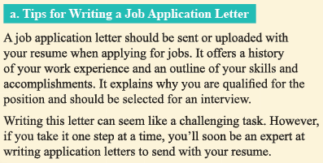

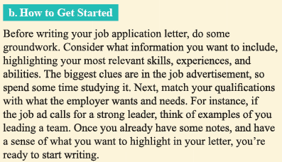

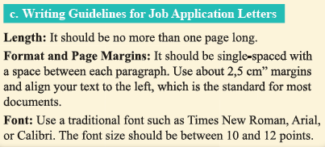

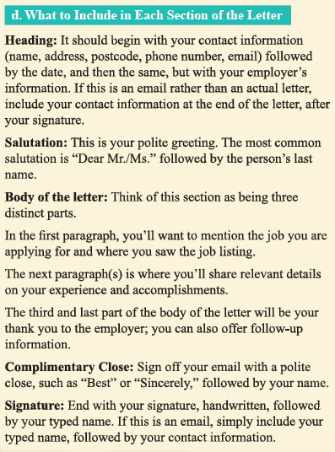

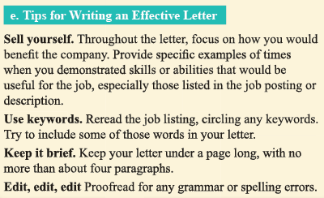

**1.- Find the following information in the informative text and write the correct letter in the line. (4 points)**

a.- length of the application letter. _______

b.- format of the application letter. _______

c.- margins of the application letter. ______

d.- size and type of font. _______

**According to the texts… (8 points)**

e.- What kind of information must be highlighted in an application letter?

_______________________________________________________________________________________________________________________________________________________________________________________________________________________________________________________________________________________________________________________________________

f.- What other documents should be attached to the application letter?

_______________________________________________________________________________________________________________________________________________________________________________________________________________________________________________________________________________________________________________________________________

g.- What should be the tone of the complementary close?

_______________________________________________________________________________________________________________________________________________________________________________________________________________________________________________________________________________________________________________________________________

h.- When are you ready to write your application letter?

_______________________________________________________________________________________________________________________________________________________________________________________________________________________________________________________________________________________________________________________________________

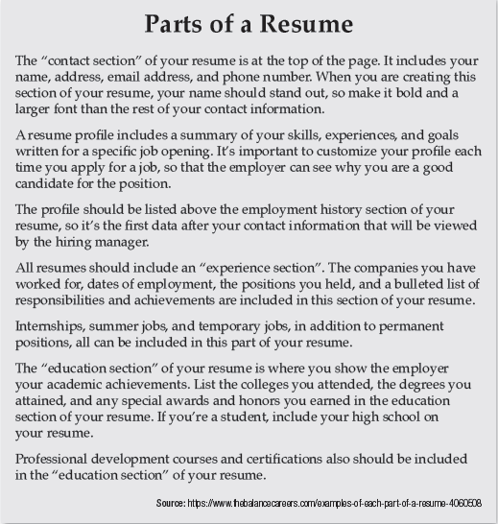

**2.- Complete these activities according to the text “Parts of a Resume”. (14 points)**

a.- Which are the sections of a resume mentioned in the text?

__________________________________________________________________________________________________________________________________________________________________________________________________________________________

b.- What should conatin the “education section”?

__________________________________________________________________________________________________________________________________________________________________________________________________________________________

c.- Which are the thigns must include your CV or resume?

__________________________________________________________________________________________________________________________________________________________________________________________________________________________

d.- What should conatin the “contact section”?

__________________________________________________________________________________________________________________________________________________________________________________________________________________________

e.- What do you should stand out on your CV or Resume?

__________________________________________________________________________________________________________________________________________________________________________________________________________________________

f.- What should conatin the “experience section”?

__________________________________________________________________________________________________________________________________________________________________________________________________________________________

g.- Look for another “sections” you can include on your CV or Resume, use the internet, ask to adults, etc.

__________________________________________________________________________________________________________________________________________________________________________________________________________________________